|  |  |
| --- | --- |
| **External Stakeholders** | **What They Can Do On The Software Created** |
| User/Customer | * They can able to access payments through whatsapp. * Can able to send money to their friends, family, relatives etc. * Use QR scan for transactions. * Can add their bank details and card details. |
| Whatsapp Pay | * Can able to generate UPI pin to secure the payment. * Can able to show previous transactions of a user in the app. * Show bank balance and transaction status. * Can able to access all banks at a single platform. |
| Bank | * Should provide UPI pin and id to the users. * Able to give access to upi apps when there is transaction ,check bank balance etc. |
| Upi Provider | * UPI id and vpa can be able to provide by third party people. |
| Credit/Debit Card Provider | * Different types of banks and financial institutions can provide credit/debit cards for their users. |

**WhatsApp Pay**

**Stake Holders:**

|  |  |
| --- | --- |
| **Internal Stakeholders** | **What They Can Do On The Software Created** |
| Project Manager | * Project Manager leads the project team and responsible to update the current project state to the client. |
| Domain Sme | * Domain sme’s can provide their ideas, opinions, thoughts to enhance the project. |
| Technical Team Members | * Developers, testers, devops experts can able to improve functional and  nonfunctional requirements. |
| Sponsor | * Who sponsors the whole project or product and provides all funds. |
| Rbi & Npci | * Who regulates all banks, financial institutions, UPI apps? * Provides all legal information, business policies, forms etc. |

|  |
| --- |
| **What are the risks :** |
| * Market competitors like phonpe, Gpay, BHIM had already created impact on UPI payments. |
| * Still most of the Indian population relay on conventional payment method. |
| * Technical glitches and heavy traffic on system since both messaging and UPI on the same data base. |
| * Cyber security issues since there are many fraud messaging and fraud transaction links to the registered mobile number. |
| * Not creating enough awareness on online payments and UPI payments to the people especially to rural areas. |

|  |
| --- |
| **SWOT ANALYSIS:** |
| **Strengths** |
| * Whats pp has already have millions of users in India so it is a added advantage over other upi apps. |
| * in whatsapp, we have already created our contacts so no need to create new list for the payments. |
| * It has strong brand value and strong distribution network. |
| * Strong technology and innovation. |
| * proven business model and huge reputation in the market |
| **Weaknesses** |
| * Reliable issues, still some of its users not satisfied about their data privacy. |
| * Circulation of fraud messages and false links may disrupt the customer trust over the transactions. |
| **Opportunities** |
| * Huge customer data base. |
| * Continues technology development. |
| * No need to download extra upi app for transactions, just update the whatsapp settings. |
| * Fast increase in upi payments and transactions in the country. |
| * Penetration rate of smart pone adaption is I in India. |
| * Addiction of whatsapp messenger by its users. |
| **Threats** |
| * high competition from its competitors like phonpe, g-pay, bhim etc. |
| * Strong government legal rules, policies. |
| * Bad reviews regarding data privacy. |

**Transition state of whatsapp pay:**

* There will be no separate app that the customers need to download to access the new feature.
* Whatsapp needs to verify your number whether it is registered with the bank or not. if not you need to give registered number to access your payments.

**Use case Diagram:**

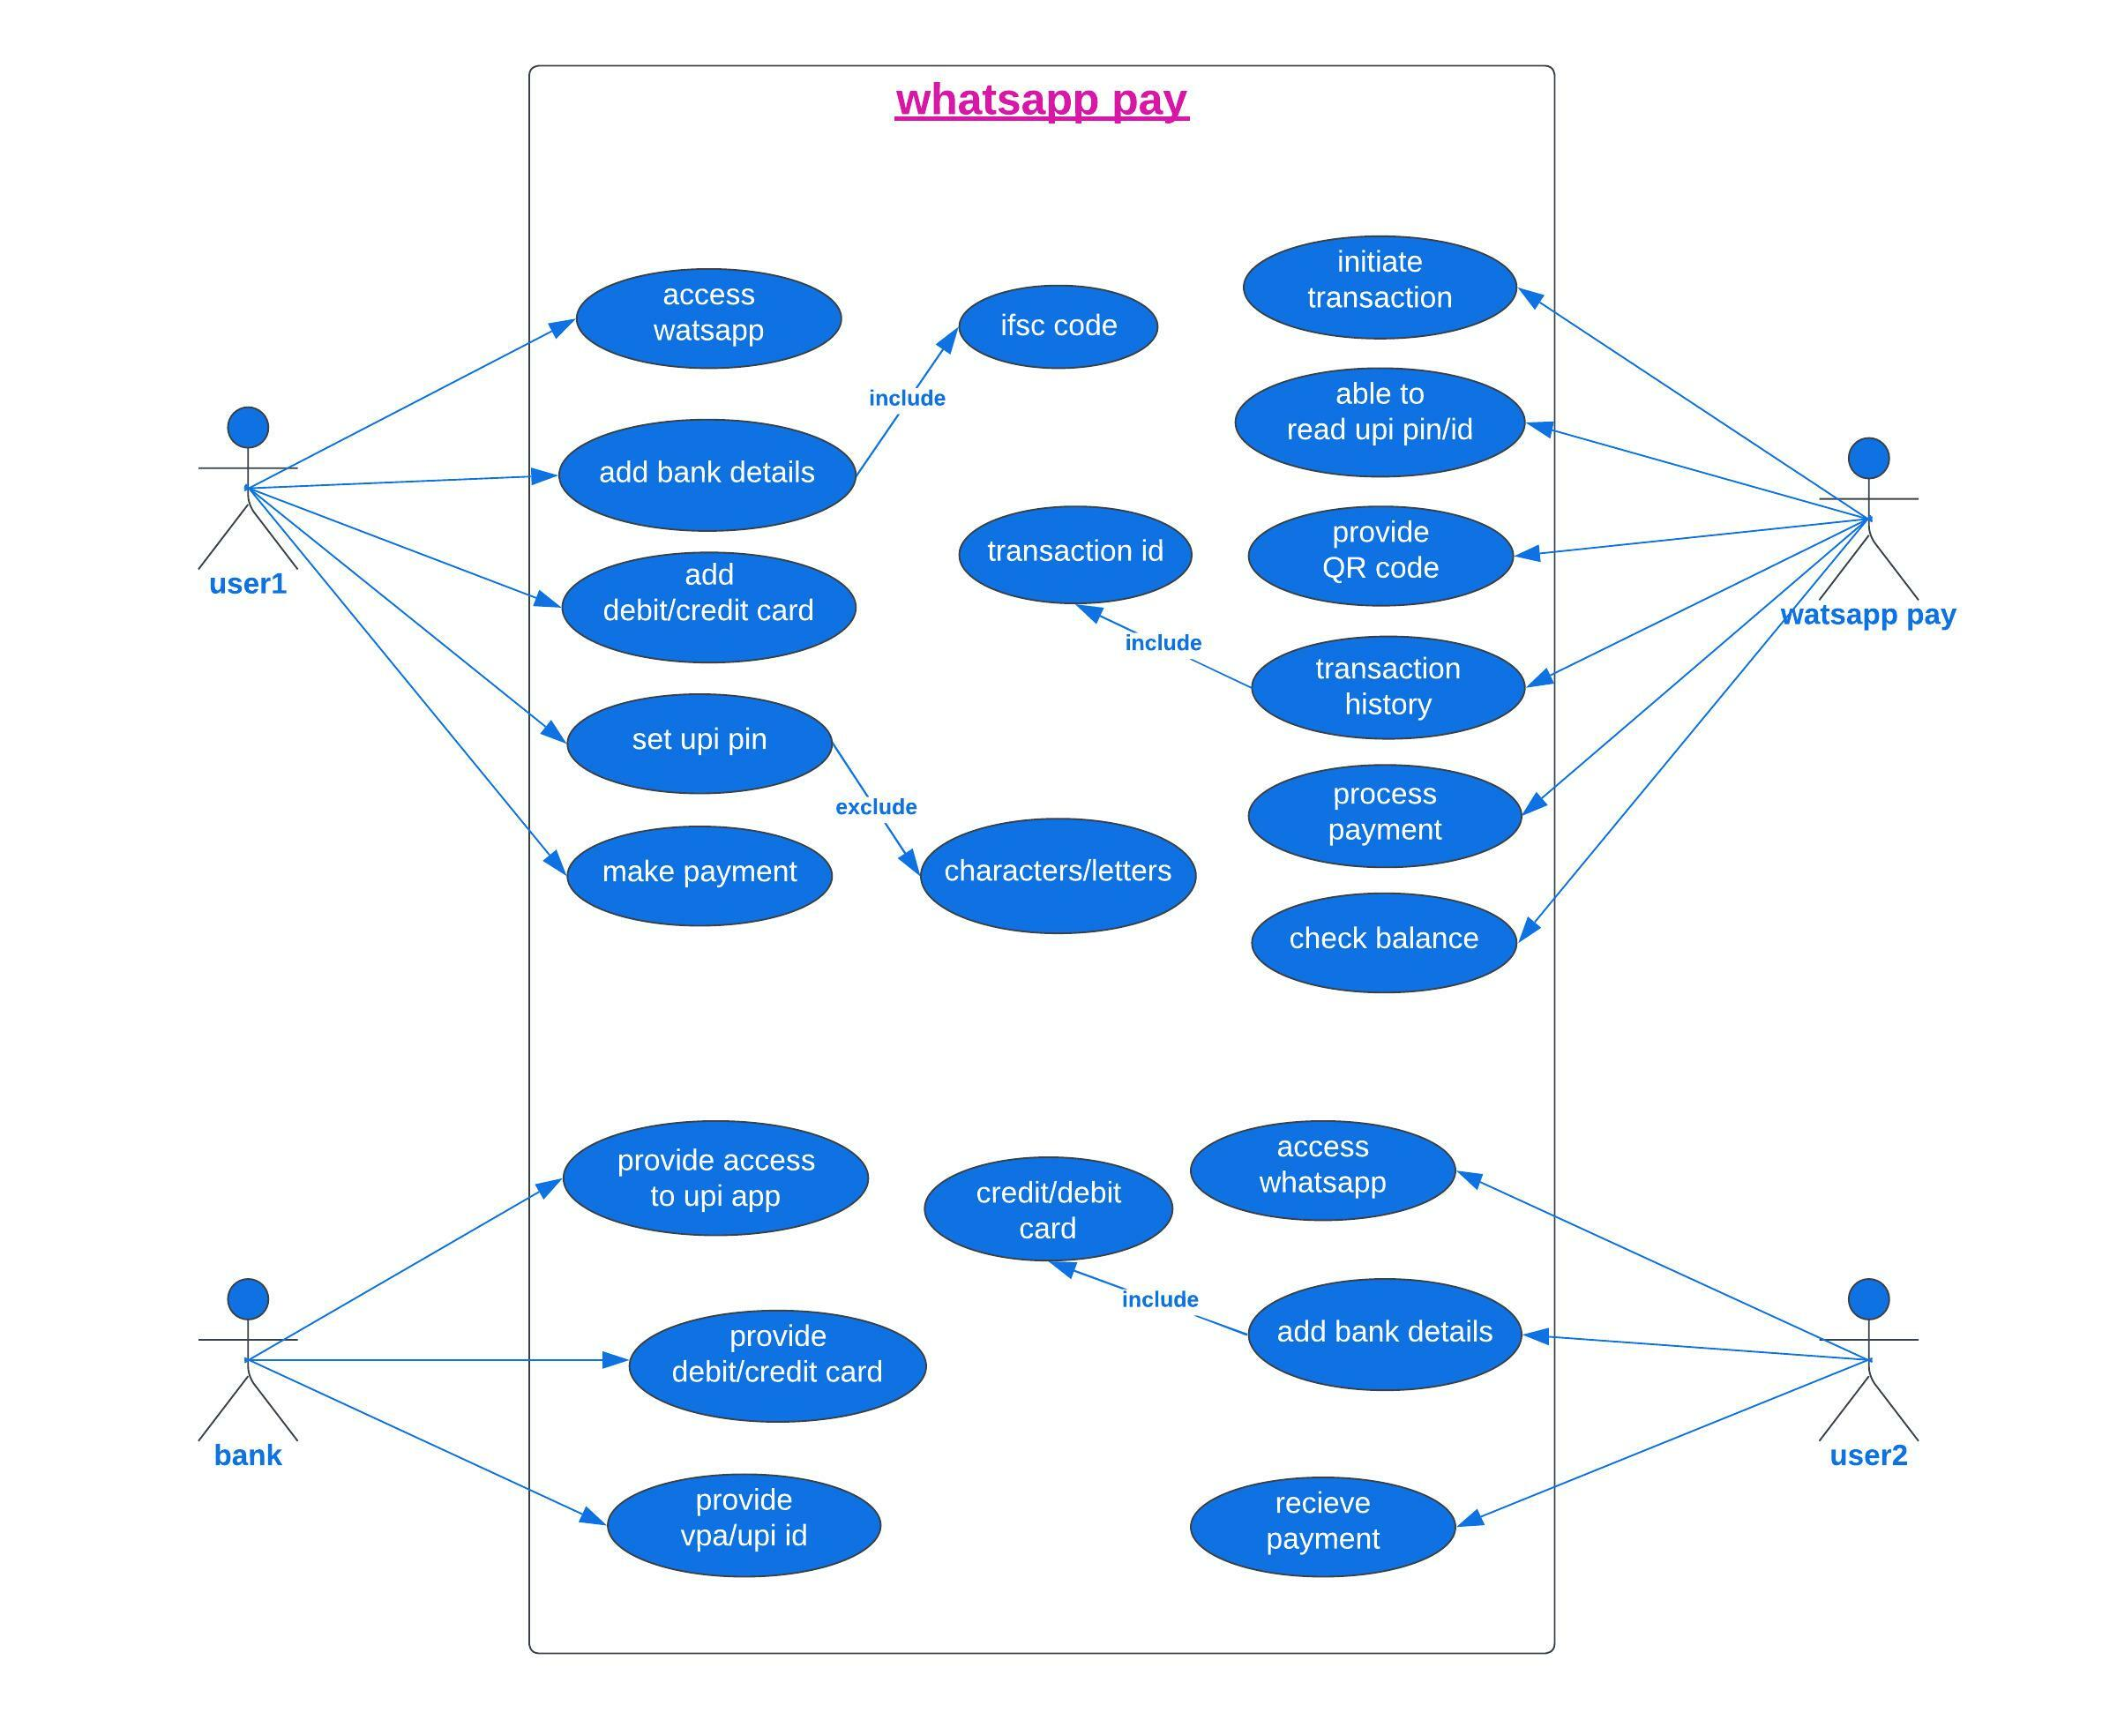

**Features that need to be developed:**

|  |  |
| --- | --- |
|  |  |
| |  |  | | --- | --- | | UPI | It is a unified payment interface, were several banks merge together to provide a single platform for online transactions/payment. | | QR scan | QR is used to scan a code to transfer amount from one account to another in less time. | | Online payment | Online transactions/payments between bank accounts through upi. | | Check bank balance | Checking bank balance online without going to bank or atm | | VPA | It is a virtual payment address which enables user to receive amount without providing account details and other details. | | Payment history | User transaction history can be seen here, so no need to rush for bank statement. | |  |

|  |
| --- |
| **In scope features:** |
| 1. Payment option in settings 2. QR code for scan 3. Upi security pin 4. Upi id/vpa 5. View bank balance 6. Add bank details 7. Add debit/credit card 8. Enter how much money need to be send 9. Transfer button 10. Payment notification message in cat window 11. Request money option |
| 1. Feature available in multiple language |

**Out of scope features:**

1. No need of new upi app
2. No need of multiple upi pin for different bank accounts
3. Separate display photo of the user is not required.
4. No need to open a new bank account

**Current state:**

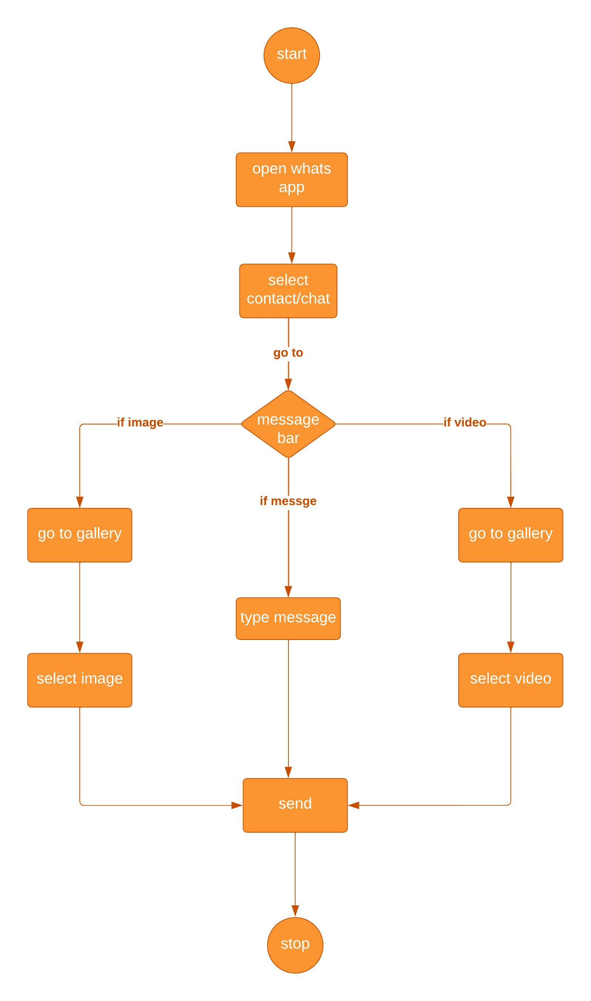

|  |  |
| --- | --- |
| **Future state:**  **Blank diagram - Page 2.jpeg**  **Functional requirements:**   1. provide payment option in settings 2. bank details 3. credit/debit card 4. QR code 5. QR scan option 6. Select contact in whatsapp contact list 7. Add money option 8. Upi security pin 9. Upi id/vpa 10. Request money option 11. Monet transfer button 12. Receive a payment notification 13. Choose Multilanguage option   **Non functional requirements:**   1. At least 1million users use whatsapp pay in 3 months 2. And in 1 year 30% of users able to use whatsapp pay 3. System should support at least 400 million users after its launch in India 4. The screens should be self-explanatory and very user friendly. |  |
| **Wireframes:**  9.png 2.png 3.png |  |
| **4.png 5.png 6.png**  **7.png** |  |